Stepanova, Varvara Fedorovna
Born 5 November 1894 in Kaunas, Lithuania
Died 20 May 1958, Moscow, USSR

Although making her mark as an innovative painter in Moscow exhibitions of 1920, it was as a designer that Varvara Stepanova is particularly known. Between 1921 and the late 1940s, she designed sets and costumes for the theatre and film (1922-1926), textiles and practical clothing for both women and men, creating a “new look” for the new Soviet citizen (from 1924), and she taught textile design at the art school, VKhUTEMAS, in Moscow from 1923. Under commissions from the State, Stepanova’s graphic design began in 1923 in which she gave a “new look” to the aspirations of the Soviet regime in books, magazines, journals and the celebration albums of the 1930s and 1940s. This “new look” was determined by geometrical models: circular patterns using a pair of compasses, linear designs using the ruler, contrast of light and dark, repeat pattern inspired by film, or simply by the potential of geometry. Stepanova assimilated the human figure, photomontage, and pure design into a visual whole made possible by her method: the modern principles of creating with geometrical models. This was the constructive process and its principles were described by Stepanova in her articles – “On Non-Objectivity Creativity in Painting” (1919), “On the Possibility of Cognizing Art” (1920), “Construction” (1920), “On Constructivism” (1921), “On Facture” (1922), “Photomontage” (1928), “Draft Syllabus for a Course in Artistic Composition in the Textile” (c. 1925), “From Clothing to Pattern and Fabric” (1929), “How We Worked on The First Cavalry” (1936).

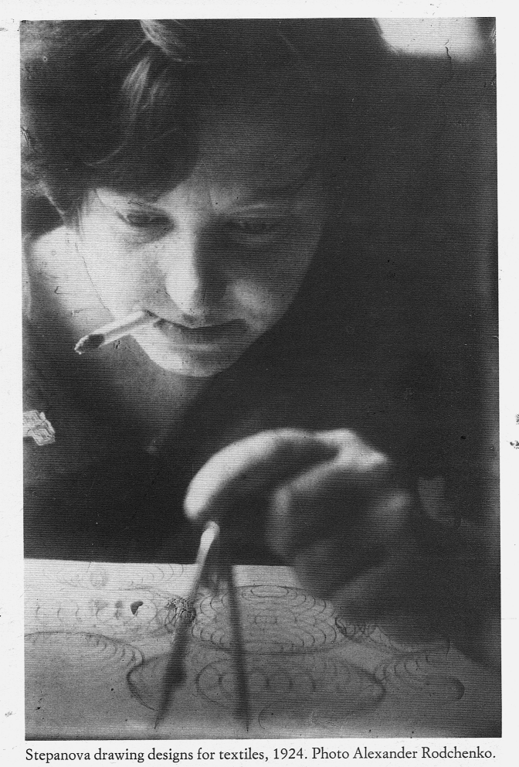

List of works
1918-1921: Paintings of geometrically determined human figures dancing, playing instruments, and so on, exhibited in 1920 – 19th State Exhibition, Moscow, Four Artists, Moscow.
1922-1926 Theatre: Death of Tarelkin (1922), An Evening of the Book (1924). Film: Alienation, 1926.
1924: Textile and Clothing Design: First State Textile Factory.
1923-1925 Professor at VkHUTEMAS, Moscow.
1925 Shows sets and costumes designed for Death of Tarelkin at Exposition International des Arts Décoratifs et Industriels Modernes, Paris.
1923-1940s Graphic Designer for State publications (V. S. Muralevich, The Modern Wireless Apparatus, 1925; E. P. Zalessky, Mountain Paths, 1925; I. N. Bernatsky, Conditions for the Stability of the Earth’s Masses, 1925; A. Menshoi, You and Me in Berlin, 1924; S. R. Dadiko and N. D. Martinov, Rolling Stock, 1925).
Magazines: Soviet Cinema, 1926-1927; Book and Revolution, 1929; The Soviet Screen, 1929; Red Students, 1929; Modern Architecture / Sovremennaia arkhitektura, 1929; Literature and Art, 1930; From Merchant Moscow to Socialist Moscow, 1932; USSR Under Construction, 1935-1940; Polygraphic Production, 1946.
Books: N. Aseev, Collected Poems in Four Volumes, 1932, Mayakovsky, Menacing Laughter, 1932.
Albums, in collaboration with Aleksandr Rodchenko: The Results of the First Five Year Plan, 1932-3; Ten Years of Uzbekistan, 1934; The First Cavalry, 1938; The Red Army, 1938; Twenty Five Years of the Kuzakh SSR, 1945.

References and further reading:
Alexander Lavrentiev and John E. Bowlt (eds.), Varvara Stepanova . A Constructivist Life,
London: Thames and Hudson, 1988.
Peter Noever (ed.), Aleksandr Rodchenko & Varvara Stepanova: The Future is Our Only
Goal, Munich: Prestel Verlag, 1991.
John E. Bowlt and Matthew Drutt (eds.), Amazons of the Avant-Garde, London: Royal
Academy of Arts, 1999.

